Spike: 1
Title: GridWorld

Author: Shafi Uzman Fassy (102608927)

Goals / deliverables:
Creating the gridworld game as specified in the specifications document using C++ coding language and demonstrate the use of simple game loop, separation of update / render code and the use of game data.

For example: UML diagram, code, reports
- For code see COS30031-2023-102608927\03 - Spike - Gridworld
- Simple Planning Flow Chart
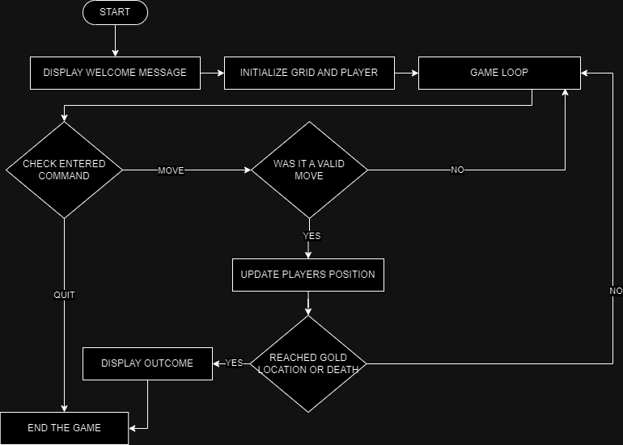

Technologies, Tools, and Resources used:
List of information needed by someone trying to reproduce this work
- Visual Studio Code
- MinGW
- C++ Cheat Sheet https://www.codewithharry.com/blogpost/cpp-cheatsheet/

Tasks undertaken:
List key tasks likely to help another developer
This section should resemble a tutorial – the goal is to allow another coder to reproduce your work following these steps.
Eg: (Good)
- Download and install Visual Studio
- Download and install DirectX
- Configure VS Project File to point to the DX lib folder
- Compile sample code
Not: (Bad)
- Read the source code
- I had some trouble with SDL, so I spent a couple of weeks doing other spikes
- Run code
- Write Spike Report

What we found out:
Describe the outcomes, and how they relate to the spike topic + graphs/screenshots/outputs as needed

Open issues/risks [Optional – remove heading/section if not used!]:
List out the issues and risks that you have been unable to resolve at the end of the spike. You may have uncovered a whole range of new risks as well.
- eg. Risk xyz (new)

Recommendations [Optional – remove heading/section if not used!]:
Often based on any open issues/risks identified. You may state that another spike is required to resolve new issues identified (or) indicate that this spike has increased your confidence in XYZ and should move on.

